**Assignment 2 SCM with GIT**

1. **Cloned the Repository for Developer 1:**

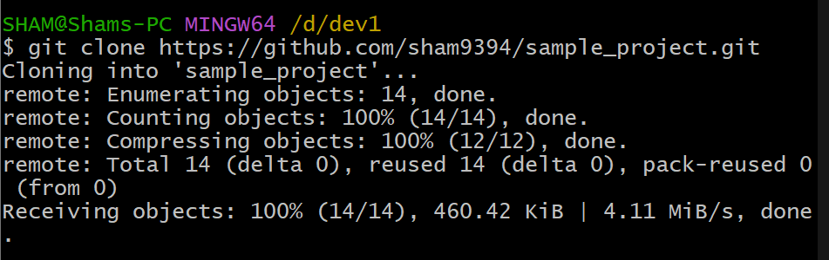

1. **Created Separate Branches from master for 2 different developers:**

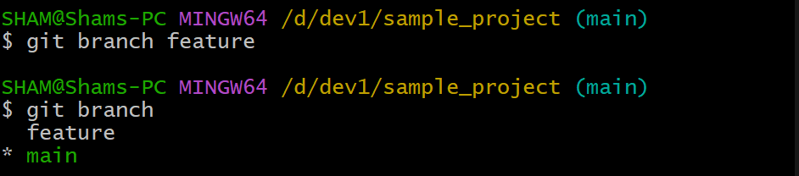

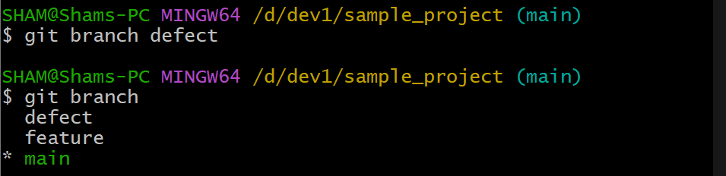

1. **Made changes in feature branch and merging into main branch:**

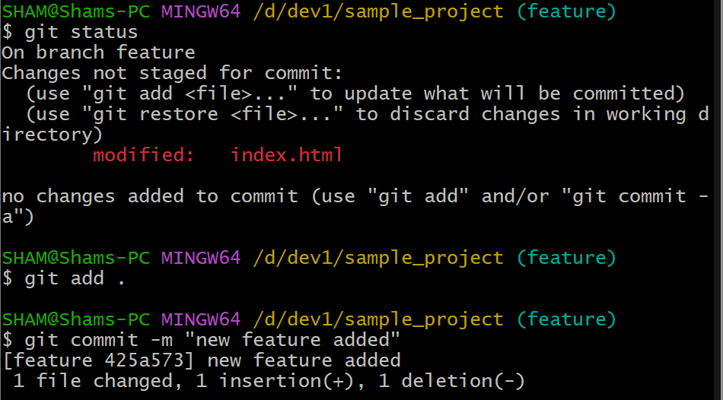

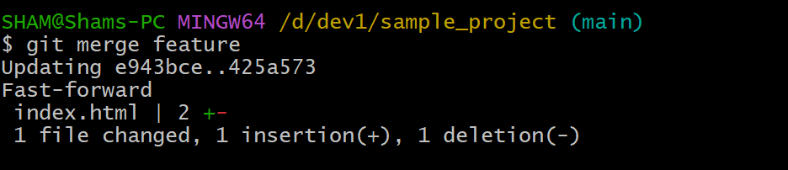

1. **New feature pushing to remote:**

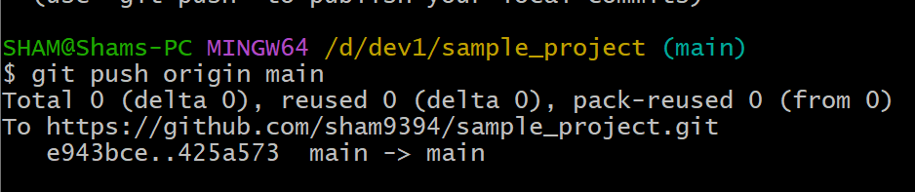

1. **Made changes in file index.html for creating conflict in defect branch:**

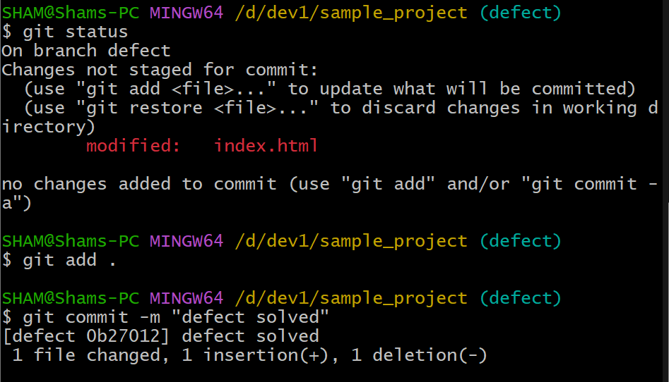

1. **Merge defect branch into main branch:**

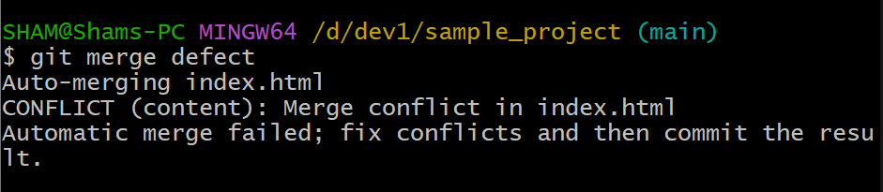

1. **Now, attempt to merge defect branch into main. Since made changes to the same function in both branches, this causes a merge conflict.**

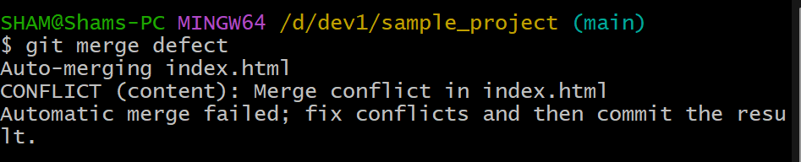

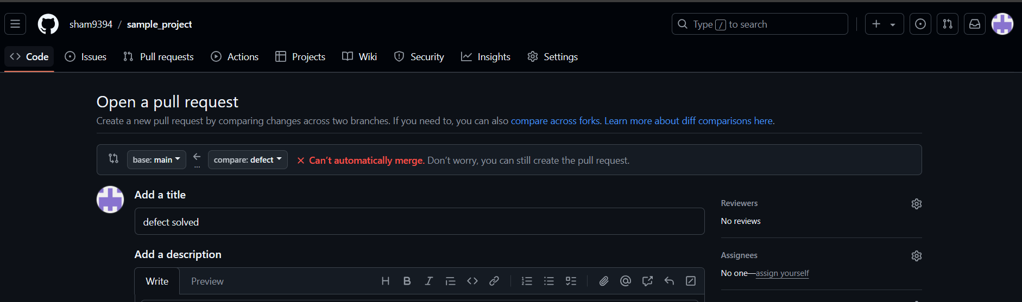

1. **Installed a Merge Tool and Resolved Merge Conflict Using Git Merge tool:**

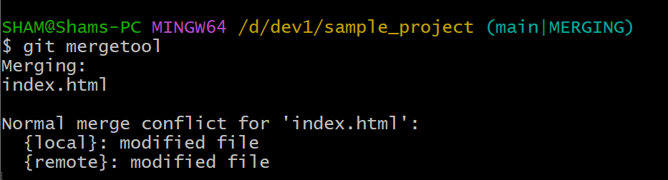

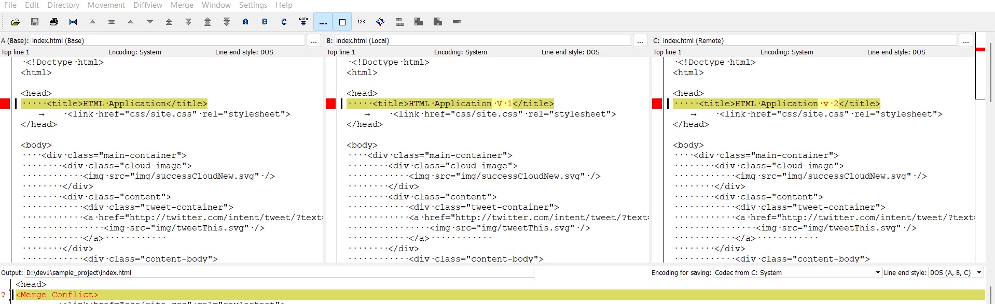

1. **Solved conflict and pushed to remote repository**

